MD. MAIN UDDIN (MAHEE)
LECTURER (PHYSICS)
DEPT. OF NATURAL SCIENCE
PORT CITY INTERNATIONAL UNIVERSITY
E-MAIL: mahee.hnbd86@gmail.com

ELASTICITY

Definition:
Elasticity is defined as the property by which a body regain its original position when the forces are withdrawn.
Stress:
When a force is applied on a body, there will be relative displacement of the particles and due to the property of elasticity the particles tend to regain their original position. Stress is defined as the restoring force per unit area.
Normal Stress:
Restoring force per unit area perpendicular to the surface is called normal stress.
Tangential Stress:
Restoring force per unit area parallel to the surface is called tangential stress.
Strain:
The ratio of the change in shape to the original shape is called strain.

There are three types of strain.
- Longitudinal strain:
The ratio of the change in length to the original length is called longitudinal strain. ($l$/L)

- Shearing strain:
Shearing strain is defined as the angle of shear measured in radians.
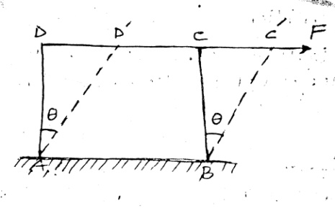
The surface AB is fixed and force is applied parallel to the surface CD, so that the body is sheared by an angle θ. The angle θ measured in radians is called the shearing strain (θ).

- Volume strain:
The ratio of the change in volume to original volume is called volume strain (v/V)
Elastic Limit:
The maximum stress up to which a body exhibits the property of elasticity is called elastic limit. If the applied force exceeds the maximum stress limit, the body does not regain its original position completely after the external force are withdrawn.
Hook’s Law:
It states that, within the elastic limit, stress is directly proportional to the position.

Stress ∞ Strain
Stress = E x strain
E = $\frac{stress}{strain}$
Here E is a constant called the modulus of elasticity.
Young’s modulus elasticity (Y):
It is defined as the ratio of normal stress to longitudinal stress.
Y = $\frac{Normal stress}{Longitudinal strain}$
Y = $\frac{F/A}{l/L}=\frac{FL}{Al}$
Modulus of rigidity (η):
It is defined as the ratio of tangential stress to shearing strain.
η ₌ $\frac{Tangential stress}{Shearing strain}$
= $\frac{F/A}{θ}$
η = $\frac{F}{∆θ}$
Bulk modulus of elasticity(K):
It is defined as the ratio of Normal stress to volume strain.

K = $\frac{Normal stress}{Volume strain}$
= $\frac{F/A}{v/V}$

$∴$ K = $\frac{FV}{Av}$
$∴$ K = $\frac{PV}{v}$ ∵ $\left[P= \frac{F}{A} \right]$
Yield Point:
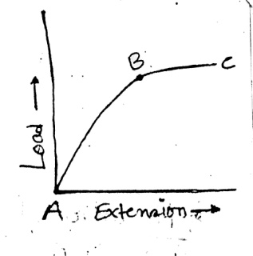
When a wire is loaded beyond the elastic limit, Hooks law longer obeyed and the extension produce in the wire is not proportional to the load. The extension is more than the corresponding increase in load. At this stage, the particles of the materials go farther apart. Now if the load is removed the particles do not regain their original positions. The point B on the figure represents yield point.
Elastic fatigue:
If a body is continuously subjected to stress and strain, it gets fatigued. Considering two tarsional pendulums A and B having similar wires. A is initially set into vibration. After A has come to rest, both the pendulum A and B are set into vibration simultaneously. It will be found that due to elastic fatigue, A comes to rest earlier than B.

Problem:
Calculate the density of load under a pressure 2 x 10⁸ Nm⁻² Density of load 11.4 x 10³ Kg/m³. Bulk modulus elasticity = 8 x 10⁹ Nm⁻².

Solution:
We Know,
K = $\frac{P}{-(\frac{dv}{v})}$ K = $\frac{ρ}{dρ/ρ}$
Also, M= vρ $dρ=\frac{ρρ}{k}$
Differentiating $dρ$ = $\frac{2 x {10}^{8}×11.4×{10}^{3}}{8×{10}^{9}}$ = 0.285$×{10}^{3} kg/m^{3}$
Vdρ + ρsv = 0 $∴$ density under applied pressure:
Vdρ = -ρdv = ρ+dρ
$\frac{dρ}{ρ}$= - $\frac{dv}{v}$ =$11.4×{10}^{3}+$ 0.285$×{10}^{3}$
= 11.685$×{10}^{3} kg/m^{3}$

** Glass is more elastic then rubber.
Glass is more elastic than rubber because for a given stress, the strain produced in glass is much less than that in rubber.

For rubber Y₁ = $\frac{FL}{Al_{1}}$ ………… (і)
For glass, Y2 = $\frac{FL}{Al_{2}}$ ………… (іі)
For the two materials, F, L and A remaining the same $l_{1}$ for rubber is more than $l_{2}$ for glass. Therefore, Y₂ is greater than Y₁.
Poisson’s ratio:
poissons ratio as the ratio of lateral strain per unit stress to the longitudinal strain per unit stress.
Let α be the longitudinal stress per unit stress and β is lateral strain per unit
Stress, within the elastic limit.
β ∞ α
β = σ α
$∴$ Poissons ratio, σ = $\frac{β }{α}$

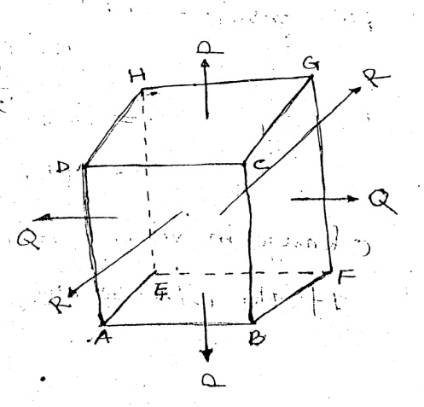
Bulk modulus (relation among K, Y and σ :
Let us consider a block of rectangular cross section having length$l$, breath band thickness t, let the blocked be subjected to outward direction as shown in the figure.
Here P is the stress acting on the faces ABFE and CDGH. Q is the stress acting on the faces AEHD and BCGF. R is the stress acting on the faces ABCD and EFGH.
Each stress produce s an extension in its own direction and a lateral contraction in the other two perpendicular directions let $α$ be the longitudinal stress and β is the lateral stress per unit stress, then
Poisons ratio, σ = $\frac{β }{α}$
Increase in length due to the stress P is P ∞ $l$ and corresponding contraction in breadth and thickness will be Pβσ and Pβt respectively.
Similarly due to the stress Q, increase in breadth is Q∞b and corresponding decrease in length and thickness will be Qβ$l$ and Qβ$t$ respectively. Also due to the stress R increase in thickness is R ∞ $t$ and decrease in the length and breadth will be Rβ$l$ and Rβ$b$.
Final length = $l$+ P$αl$- Q$βl$ - R$βl$
Final breath = b + Q$αb$– P$β$b – R$β$b
Final thickness = t + R$α$t – P$β$t – Q$β$t
Final volume = $l$bt [1 + P$α$ – (Q+R )$β$] × [1+ Q$α$ - (P+R) β] × [1 + R$α$ - (P+Q)β]
= $l$bt [1 + (P+Q+R)$α$ × -2β (P+Q+R)]
= $l$bt [1+ (P+Q+R) ($α$-2β)]
Change in volume = $l$bt (P+Q+R) ($α$-2β)
If the stress are equal, P=Q=R
Change in volume = $l$bt (3P) ($α$-2β)
$∴$ Strain = $\frac{lbt (3P) (α-2β)}{lbt}$
= 3P ($α$-2β)
Bulk modulus, K = $\frac{P}{(3P) (α-2β)}$
K = $\frac{1}{3 (α-2β)}$ ----------- (і)
K = $\frac{1}{3α (1-2. \frac{β}{α} )}$
K = $\frac{1}{3α (1-2. σ )}$ ∵ [ σ = $\frac{β}{α}$ ] --------- (іі)
But, Y = $\frac{1}{α}$
$∴$ K = $\frac{Y}{3(1-2σ)}$ ---------- (ііі)

*** Relation among elastic constants (Y, η, K, σ)
The various equations are,

Y = $\frac{1}{α}$ ………… 1
K = $\frac{1}{3 (α-2β)}$ ………… 2
η = $\frac{1}{2(α+β)}$ ………… 3
From 2 and 3
$α-2β= \frac{1}{3K}$ ………… 4
2$α+2β$ = $\frac{1}{η}$ ………… 5
Adding 4 and 5, then simplifying

3$α$ = $\frac{1}{3K}$ + $\frac{1}{η}$
$\frac{3}{Y}$ = $\frac{1}{3K}$ + $\frac{1}{η}$ ………… 6
From equation 6,

Y = $\frac{9ηK}{η+3K}$ ………… 7
$η$ = $\frac{3KY}{9K-Y}$ ………… 8

K = $\frac{Yη}{9η-3Y}$ ………… 9
From eq^{n} 3,
η = $\frac{1}{2(α+β)}$ = $\frac{1}{2α (1+\frac{β}{α} )}$
η = $\frac{Y}{2(1+σ)}$ ………… 10
σ = $\frac{Y}{2η }$ - 1 ………… 11
Multiplying eq^{n} 4 by 2 and subtracting it from eq^{n} 5 we get,
σβ = $\frac{1}{η}$ - $\frac{2}{3K}$
β = $\frac{3K-2η}{18ηK}$ ………… 12
Poisons ratio,
σ = $\frac{β }{α}$ = βY = $\left(\frac{3K-2η}{18ηK}\right)$ $\left(\frac{9ηK}{η+3K}\right)$
$∴$ σ = $\frac{3K-2η}{η+3K}$ ………… 13

Limiting values of σ :
We know, η = $\frac{1}{2(α+β)}$ = $\frac{1}{2α (1+\frac{β}{α} )}$ = $\frac{Y}{2(1+σ)}$ ………… 1 $\left[Y= \frac{1}{α}, σ=\frac{β }{α}\right]$
And, K = $\frac{1}{3 (α-2β)}$ = $\frac{1}{3α (1-2.\frac{β}{α} )}$ =$\frac{Y}{3(1-2σ)}$ ………… 2
From equation 1 and 2, we get
Y = 3K (1-2σ) = 2η (1+σ)
$∴$ 3K (1-2σ) = 2η (1+σ) ………… 3

(І) If the poisson’s ratio is a positive quantity, as K and η are always positive,
(1-2σ) > 0
2σ < 1
σ < $\frac{1}{2}$
(ІІ) If the poisson’s ratio is a negative quantity, for η and K to be positive,
(1+σ) > 0
σ > -1
It means that the values of σ lies between -1 and $\frac{1}{2}$

Math:
- The modulus of rigidity and poisons ratio of the material of a pair are 2.87×10¹⁰ N/m² and 0.379 respectively. Find the value of Youngs modulus of the materials of the wire L.

- Calculate the Poisson’s ratio for the material, given Y = 12.25×10¹⁰ N/m² and η = 4.55×10¹⁰ N/m²

MD. MAIN UDDIN (MAHEE)
LECTURER (PHYSICS)
DEPT. OF NATURAL SCIENCE
PORT CITY INTERNATIONAL UNIVERSITY
E-MAIL: mahee.hnbd86@gmail.com

Newton’s Motion Law
First law:
Everybody contains in its state of rest or of uniform motion in straight line except the external forces to changes the state.
Second law:
The rate of change of momentum of a body is directly proportional to the force and the change of momentum takes place along the direction of the force.
Third law:
To every action has an equal and opposite reaction.
Friction:
Friction is the force that resists relative motion between two bodies in contact.

Advantage of Friction:
- We can write on paper or on board by friction.
- Friction helps in the apply in brake.
- It helps in walking on the floor.

Dis-advantage:
- Reduce the efficiency of vehicles.
- Wearing and tearing machinery parts occur.

**Classification of frictional force:
There are two types of frictional force.
- Static frictional force: The frictional force that acts between a surface and an object. There is no relative motion between them, is called static force.
- Kinetic frictional force: When there is a relative motion than the frictional force between them is called kinetic frictional fo

Force

Force:
Force is that which applied on a body at rest or when applied on a body in motion changes or tries to change its states of motion.

Properties of force:
- Since pull or push as both magnitude and direction so force is a vector quantity.
- Force is always applied in pairs if the object A applies force on B that the option B applies force on A.
- Force can produce acceleration on a body.
- Force can deforms a body when we pull a piece of a rubber or spring holding in its two ends, them it is deformed types of force.

Types of force:
1. Fundamental force, again it has four types,
- Gravitational force.
- Electromagnetic force.
- Strong nuclear force.
- Weak nuclear force.
- Gravitational force:
The force attraction between any two objects in the universe is called gravitational force.
- Electro-magnetic force:
The force of attraction or repulsion applied by two charges due to their changes is called electromagnetic force.
- Strong nuclear force:
The force that keeps the nucleic in a nucleus together is called strong nucleus force.
- Weak nuclear force:
The short ranges force which acts within fundamental particles of the nucleus unstable is called weak nuclear force.

Conservative force:
A force is said to be conservative if the work done by the force on a particles in a round trip is zero is called conservative force. Exa: Force of gravity.
Non-Conservative force:
A force is said to be non-conservative if the work done by the force on a particles in a round trip is not zero is called non-conservative force. Exa: Frictional force.

Difference between conservative & non-conservative force:
Sl No. | Conservative force | Non-Conservative force
1 | A force is said to be conservative if the work done by the force on a particles in a round trip is zero is called conservative force. | A force is said to be non-conservative if the work done by the force on a particles in a round trip is not zero is called non-conservative force.
2 | The work done by the conservative force can restored fully. | The work done by the Nonn-conservative force can not be restored fully.
3 | The work done by the conservative on a particles does not depend on the path followed but on the initial and final position of the particles. | The work done by the non-conservative on a particles depends on the path followed along the initial and final position of the particles.
4 | In case of conservative force the system obeys the law of conservation of mechanical energy. | In case of non-conservative force the system does not obeys the law of non-conservational of mechanical energy.
5 | The work done zero.  Example: Force of gravity. | The work done not zero.  Example: Frictional force.

Work, Energy & Power
Definition:
If a force acts on a body & causes some displacement along the force, then it is said that the force has done some work. The product of force and displacement along the force is called work.
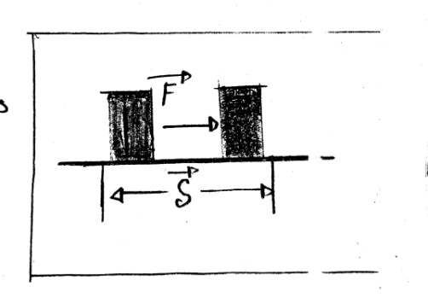
Let a constant force F is acting on a body & due to this force displacement S occurs along the straight line of the force. Then the work W done by the force on the body will be W=FS.
Positive work:
If force acting on a body along the direction of the force or if there is a component of the displacement along the force is called positive work.
Negative work:
If force acting on a body along the opposite direction of force or if there is a component of the displacement opposite to the force, then the product of the force and the component of displacement opposite to the direction of the force is called negative force.

Energy
Definition:
The ability of doing work of a body is called energy.

Various kinds of energy are given below__
- Mechanical energy.
- Heat energy.
- Sound energy.
- Light energy.
- Magnetic energy.
- Electrical energy.
- Chemical energy.
- Nuclear energy.
- Solar energy.
Kinetic energy:
The ability of doing work of a moving body due to its motion is called kinetic energy.
Kinetic energy of a body is K.E = $\frac{1}{2}$ mv²
Here, m is the mass of the body.
V is the velocity of the body.
Work Energy Theorem:
The work done on a body by an applied force is equal to the change of its kinetic energy.
Deduction:
Suppose a constant force (F) acts on a body of mass (m) moving with a velocity (V₀). Due to this, the body gets a velocity V & comes a distance X in the direction of the applied force,

W=FX ………… (і)
It is the content acceleration of the body, then according to Newton’s 2nd law,

F=ma
Putting this value in eq^{n} 1,

W=max ………… (іі)
But from equation of motion we know,
V² = V₀²+2ax
Or, 2ax = V² - V₀²
Or, ax = $\frac{V2 - V02}{2}$
Putting the value of ax in eq^{n} 2
W = m$\left(\frac{V2 - V02}{2}\right)$
= $\frac{1}{2}$mv² - $\frac{1}{2}$mv₀²
W = K – K₀
Potential Energy:
The ability of doing work gained by a body due to its change of normal position is called potential energy.
Explanation:
When a spring or rubber band is stretched, potential energy is stored in it due to this extend position . Because it can do some work, when it returns to its original position. It can displace another body.
To raise an object above the ground, some work has to be done against the force of gravitational potential energy because when this object falls to the ground, it can do some work on another body, it can raise another body.

Distinction between Kinetic & Potential Energy:
Kinetic Energy | Potential Energy
The ability of doing work of a moving body is kinetic energy. | The ability of doing work gained by a body due to its change of normal position is called potential energy.
If v be the velocity of a body of mass m then its kinetic energy is $\frac{1}{2}$ mv². | If a body of mass m is at a height h from the earth surface then its provisional potential energy is mgh.
No reference object or reference plane is necessary to determine the kinetic energy. | Potential energy is determined with respect to reference object or reference plane. The gravitational potential energy depends on the plane or object where the height is measured.
If a body does not have velocity, it does not posses kinetic energy. | If a body not has any potential energy with respect to particular plane, it may posses potential energy with respect to another plane.

Principle of Conservation energy
Statement:
Energy can be neither is created nor be destroy, It can be converted from one to another. The total energy of the universe remains constant.
Explanation:
Energy can be transformed from one kind to another. When energy transforms from one from to another, no energy is lost. If one body losses some energy then the another body gains the same amount of energy. Actually, we can’t create or destroy energy. Hence the total energy of the universe remains same, whatever energy was there at the moment of the creation of the universe, the same amount of energy is here today also. This is the conservation of energy.

Conservation of mechanical energy
Statement: If any conservation force acts on a system then the sum of kinetic & potential energies of the system remains constant.
i.e – Kinetic energy + Potential energy = Constant
Explanation:
If conservative force acts on a system, then the mechanical energy of the system conserves. In that case, the sum of kinetic energy & potential energy is the mechanical energy remain constant. If the potential energy increase & if the potential energy of the system decrease, then the kinetic energy increase. But their sum does not change. Let the initial potential & kinetic energies of a system v_{i} & k_{i} respectively when a conservative force acts on the system let the final potential & kinetic energies of the system become v_{f} & k_{f} respectively. Now according to the principle of mechanical energy.

V_{i} + k_{i} = V_{f} + k_{f}

Math:
- The mass of neutron 1.67×10⁻²⁷kg & is moving with 4×10⁴ ms⁻¹ velocity. Find out its kinetic energy.

Solution:
Here,
Mass of Neutron, m = 1.67×10⁻²⁷kg
Velocity of Neutron, v = 4×10⁴ ms⁻¹
We know, kinetic energy

K = $\frac{1}{2}$ mv²
= $\frac{1}{2}$ × 1.67×10⁻²⁷ × $\left(4×104\right)$²
= 13.36×10⁻¹⁹ J (Ans)
- The bullet of a rifle cans just penetrate one plank. If the velocity of the bullet is made five times then how many similar planks can be penetrated?

Solution:
Let the mass of the bullet is m & velocity v, to penetrate the plank are required kinetic energy is k, k₁ ₌ $\frac{1}{2}$ mv² ………… (і)

When the velocity is made five times, the kinetic energy k₂ will be
k₂ = $\frac{1}{2}$ m(5v)²
= $\frac{1}{2}$ m 25v²
= 25× $\frac{1}{2}$ mv²
$∴$ K₂ = 25 × k₁

Power
Definition:
The rate of doing work is power.
Explanation:
If work w is done in time t,
Then power, P = $\frac{w}{t}$ ………… (і)
If, W=Fs
$∴$ P = $\frac{Fs}{t}$
$∴$ P = $\frac{mgh}{t}$

Distinction between Work & power:
Work | Power
The product of force & displacement along the force is called work. | The rate of doing work is power.
There are two kinds of work. a) Positive work. b) Negative work. | Power does not have any classification.
The dimension of work is ML²T⁻². | The dimension of power is ML²T⁻³.
The unit of work is Joule. | The unit of power is Watt.

Distinction between Energy & Power:
Energy | Power
The ability of doing work of a body is called energy. | The rate of doing work is power.
The dimension of energy is ML²T⁻². | The dimension of power is ML²T⁻³.
The unit of energy is Joule. | The unit of power is Watt.
Energy has different forms, energy transform from one to other form. | Power does not have any classification.
Energy is determined by the amount of total work done. Hence time is not required in the determination of energy. | Total work is not necessary in the determination of power.

Co-efficient of static force:
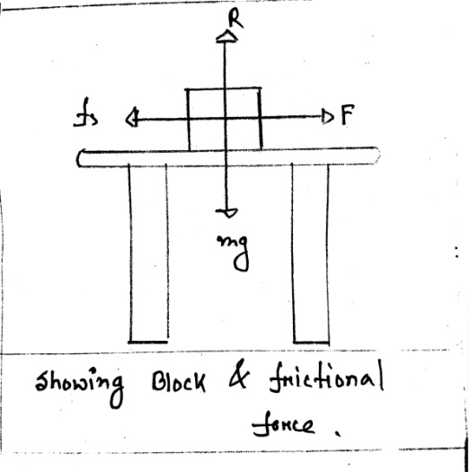
When two objects contact with each other, the ratio of static friction and the normal reaction force is called the co-efficient static friction.
if the value of static friction f_{s} & the normal reaction force is R then the co-efficient of static friction μ will be,
μ_{s =} $\frac{f_{s}}{R}$
$∴ f_{s}$ ₌ μ_{s}R.

Co-efficient of Kinetic friction:
when there is a relative motion between two surface then the ratio of kinetic friction & the normal reaction force is called the co-efficient of kinetic friction.
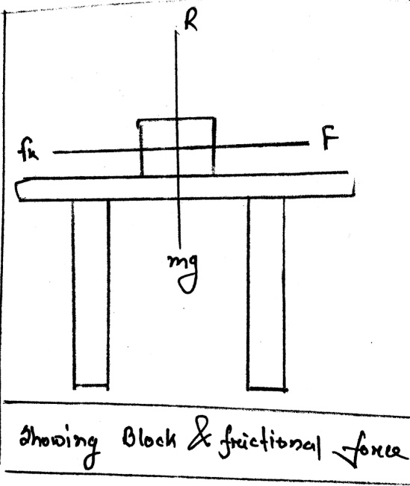
If the value of kinetic friction is f_{k} & the normal reaction force is R, then the co-efficient of kinetic friction will be,
μ_{k =} $\frac{f_{k}}{R}$
$∴ f_{k}=$μ_{k}R

Math:
- A box mass 70kg pulled over the floor the floor with a horizontal force 500N, when it moves the co-efficient of friction between the box & floor becomes of 0.50, calculate the acceleration of the box.
Solution:
Here, mass of box (m) = 70kg
Normal force (R) = mg
= 70×9.8
= 686 N.
We know, μ_{k =} $\frac{f_{k}}{R}$
$f_{k}=$μ_{k}R
= 0.5×686 =343N
Again, F - $f_{k}$ = ma
Or, 500 – 343 = ma
Or, 157 = ma
Or, a = $\frac{157}{70}$ = 2.24ms⁻²
$∴$ The acceleration of the box is 2.24ms⁻²
Law’s of static friction
- Static frictional force always acts opposite to the motion.
- The value of static frictional force is always proportional to the normal reaction force.
- The static frictional force depends on the nature of the surface of contact but not the area of the surface or contact.

Angle of Friction:
The angle between normal & resultant reaction force obtained by the vector additional of normal force in case of static friction is called the angle of friction.
Explanation

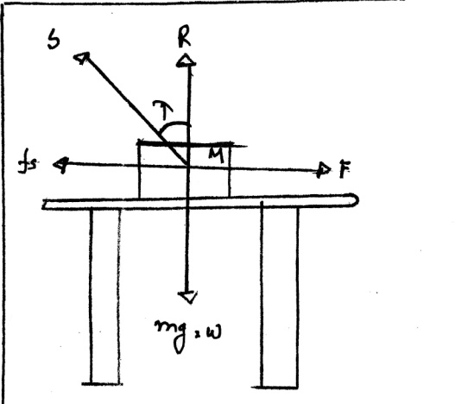

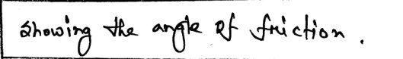

in figure , the resultant reaction s is obtained by the addition of frictional force $f_{s}$ & the normal reaction R. the angle λ between these resultant reactions s & normal reaction R is the angle of friction.
Relation between angle of friction & co-efficient of static friction:-
R = s cos $λ$
$f_{s}$ = s sin $λ$
The co-efficient of static friction,
μ_{s =} $\frac{f_{s}}{R}$ ₌ $\frac{ s sin λ}{s cos λ}$ _{= s tan}$λ$
$∴$ μ_{s = s tan}$λ$

Angle of Repose:
The angle between inclined & horizontal plane for which an object on the inclined plane is about to slide is called angle of repose.
Explanation:
in figure, Block (A) is placed on an inclined plane OX. The inclination of the plane OY with the horizontal plane can be changed according to own will. The weight of block is W & the frictional force is f_{s}. on in increasing the inclination of OX plane is made θ then the block A is about to move. At this state we can write,
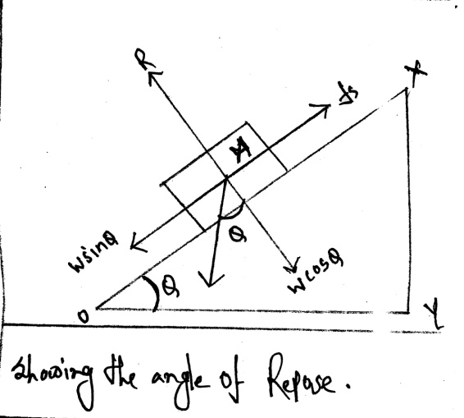
R = W$cos θ$
f_{s} = W $sin θ$
Co-efficient of static friction_
μ_{s =} $\frac{f_{s}}{R}$
₌ $\frac{ w sin θ}{w cos θ}$
_{= w tan}$θ$
$∴$ μ_{s = w tan}$θ$
Here θ is the angle of repose of the block A on the plane OX, we know
μ_{s} = _{tan}$θ$
_{tan}$θ$ = _{tan}$λ$

Math-01:
The weight of a wooden block is 400N is placed on a floor. If a force of 160N is applied to slide over the floor, calculate the co-efficient of static friction between the floor & wooden block.
Solution:
Given there, R = 400N
f_{s} = 160N
we know, ₌ $\frac{f_{s}}{R}$
= $\frac{160}{400}$
= 0.4N
$∴$ μ_{s} = 0.4N
Math-02:
A mass is resting on a flat surface which has a normal force of 98N, with a co-efficient of static friction 0.35, what force would it take to move the object.
Solution:
Given there, R = 98N
μ_{s} = 0.35N
we know, μ_{s} = $\frac{f_{s}}{R}$
$∴$ f_{s} = μ_{s}R
= 98×0.35
= 34.3N
$∴$ f_{s} = 34.3N

Math-03:
A 15 kg piece of wood is placed on another piece of wood. There is 35N of static friction measured between them. Determine the co-efficient of static friction between the two pieces of wood.
Solution:
Given there, f_{s} = 35N
We know that, w = R = mg
= 15×9.8
= 147N
We know, μ_{s} = $\frac{f_{s}}{R}$
= $\frac{35}{147}$
= 0.24N
$∴$ f_{s} = 0.24N

